C PROGRAMMING TO CHECK THE GIVEN STRING IS A PALINDROME OR NOT

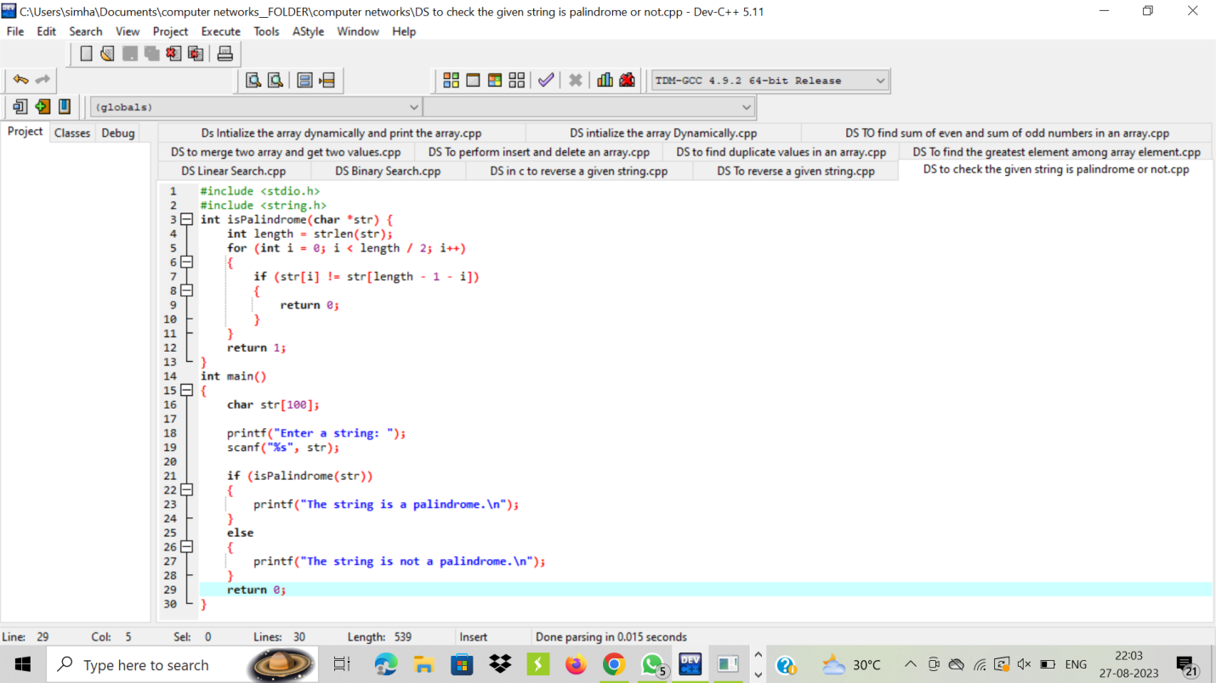

OUTPUT:

